Event Sourcing
# Source: AI Source: Provided by: [Data Path: Persons Table -> ID Column: 1, Name_En Column: Motasem Essam] -> From: [ChatGPT] on [1/23/2026]
Event Sourcing is an architectural pattern where the system stores all changes as a sequence of events, instead of storing only the current state.
👉 Instead of saving “what the data is now”, you save “what happened over time”

🔑 Key Idea
# Source: AI Source: Provided by: [Data Path: Persons Table -> ID Column: 1, Name_En Column: Motasem Essam] -> From: [ChatGPT] on [1/23/2026]
- State is derived by replaying events
- Events are immutable (never changed)
- Provides a complete history of the system

🧱 Structure
# Source: AI Source: Provided by: [Data Path: Persons Table -> ID Column: 1, Name_En Column: Motasem Essam] -> From: [ChatGPT] on [1/23/2026]
Command → Event → Event Store → State (reconstructed)
- Command → Request to change data (e.g., CreateOrder)
- Event → What actually happened (OrderCreated)
- Event Store → Stores all events
- State → Rebuilt by replaying events

🧩 Example – Bank Account
# Source: AI Source: Provided by: [Data Path: Persons Table -> ID Column: 1, Name_En Column: Motasem Essam] -> From: [ChatGPT] on [1/23/2026]
Events:
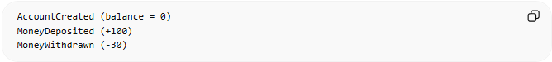
AccountCreated (balance = 0)
MoneyDeposited (+100)
MoneyWithdrawn (-30)
Current State:
0 + 100 - 30 = 70
👉 The system rebuilds balance by replaying events

💻 Example Code (Conceptual)
# Source: AI Source: Provided by: [Data Path: Persons Table -> ID Column: 1, Name_En Column: Motasem Essam] -> From: [ChatGPT] on [1/23/2026]
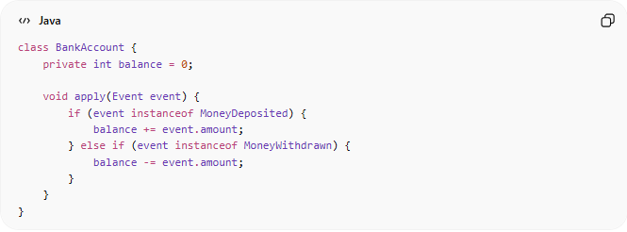
class BankAccount {
private int balance = 0;

void apply(Event event) {
if (event instanceof MoneyDeposited) {
balance += event.amount;
} else if (event instanceof MoneyWithdrawn) {
balance -= event.amount;
}
}
}

❌ Bad Example (Traditional State Storage)
# Source: AI Source: Provided by: [Data Path: Persons Table -> ID Column: 1, Name_En Column: Motasem Essam] -> From: [ChatGPT] on [1/23/2026]
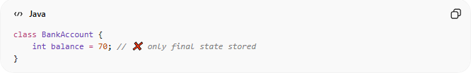
class BankAccount {
int balance = 70; // ❌ only final state stored
}
👉 Problems:
- No history
- Hard to debug
- No audit trail

✅ Good Example (Event Sourcing)
# Source: AI Source: Provided by: [Data Path: Persons Table -> ID Column: 1, Name_En Column: Motasem Essam] -> From: [ChatGPT] on [1/23/2026]
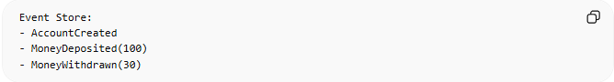
Event Store:
- AccountCreated
- MoneyDeposited(100)
- MoneyWithdrawn(30)
👉 Benefits:
- Full history
- Easy debugging and auditing
- Can rebuild any past state

🔄 Use Cases
# Source: AI Source: Provided by: [Data Path: Persons Table -> ID Column: 1, Name_En Column: Motasem Essam] -> From: [ChatGPT] on [1/23/2026]
- Financial systems (banking, payments)
- Audit logs and compliance systems
- Event-driven architectures
- Systems needing history tracking

⚠️ Common Mistakes
# Source: AI Source: Provided by: [Data Path: Persons Table -> ID Column: 1, Name_En Column: Motasem Essam] -> From: [ChatGPT] on [1/23/2026]
- Not handling event versioning ❌
- Replaying too many events (performance issue) ❌
- Mixing commands and events ❌

💡 Key Idea
# Source: AI Source: Provided by: [Data Path: Persons Table -> ID Column: 1, Name_En Column: Motasem Essam] -> From: [ChatGPT] on [1/23/2026]
Event Sourcing treats events as the source of truth, not the current state

🧾 Summary
# Source: AI Source: Provided by: [Data Path: Persons Table -> ID Column: 1, Name_En Column: Motasem Essam] -> From: [ChatGPT] on [1/23/2026]
- Store events instead of state
- Rebuild state by replaying events
- Enables auditability, debugging, and flexibility

